

Project Executable Files

Date | 02 July 2026
Team ID | xxxxxx
Project Name | OptiCrop: Smart Agricultural Production Optimization Engine
Maximum Marks | 3 Marks

Project Executable Files
This section requires submission of all executable and deployable files for your project. Ensure all files are properly organized, named, and uploaded to the specified submission platform. The evaluator must be able to run or deploy your solution using the provided files and instructions.

Step 1: Submission Checklist

S.No | Item to Submit | Submitted (Yes / No / NA)
1 | Complete source code (all files and folders) | Yes
2 | README / Setup Guide (instructions to run the project) | Yes
3 | requirements.txt / dependency file | Yes
4 | Database schema / seed files (if applicable) | NA
5 | Environment configuration file (.env.example) | No
6 | Deployed application URL (if hosted) | No
7 | APK / Executable binary (if applicable) | NA
8 | Dockerfile / Containerization configuration | NA
9 | Test files and test results | Yes
10 | Demo video / Walkthrough | Yes (if prepared) / No (if not prepared)

Step 2: File / Folder Structure
Provide an overview of your project's file and folder structure below:

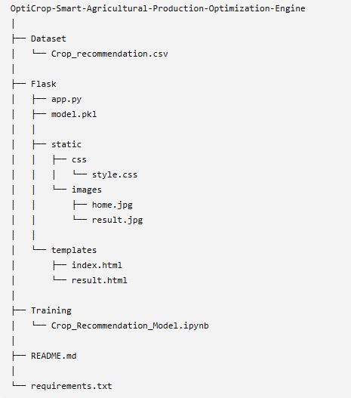

Step 3: Deployment / Access Details

Field | Details
Hosted / Deployed URL | Not Hosted
Login Credentials  (Demo) | Not Applicable
Platform / Hosting  Provider | Local System
Repository Link | https://github.com/Charishmakongara/OptiCrop-Smart-Agricultural-Production-Optimization-Engine
Demo Video Link

Step 4: Run Instructions
Provide clear, step-by-step instructions for the evaluator to run your project locally:

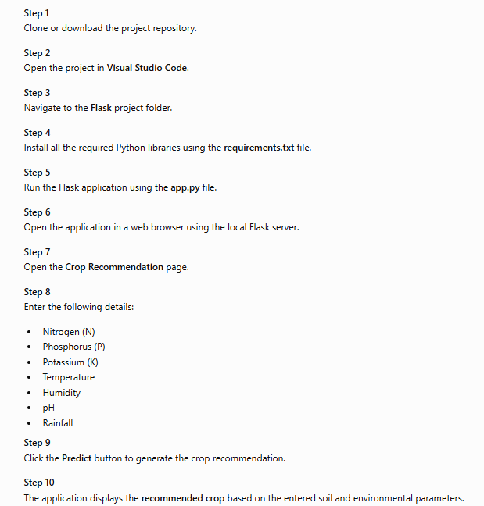

Step 5: Known Issues / Limitations

S.No | Known Issue / Limitation | Workaround / Status
1 | Application requires manual input of soil parameters. | Users must enter accurate values for better predictions.
2 | Model is trained on the available dataset only. | Performance can be improved by using larger and updated datasets.
3 | Weather API and fertilizer recommendation are not integrated. | These features can be added in future enhancements.

